CRM Brief
CRM
Candidate Facing
- Candidates can use the CRM to register with our agency. We can provide them with a automatic email with all details to do the registration by the consultant inputting their basic information on to the CRM.
- During registration automatic emails can be sent by consultant to the candidate if they haven’t included certain documentation (chaser messages)
- Candidates can log in to the system to check the progress of their application. Ie have we got all their compliance, have we got references back yet. As consultants approve certain documentation they will tick off on the system and this will in turn show to the candidate on their side.
- Once they are fully compliant candidates will be able to send direct messages to the consultant through the CRM.
- They will also be able to access all the training programs we have added to the system. They can grade these programs and leave reviews of their experience with that program
- They will also be able to view all the details regarding their booking/placement. (Bookings page) Ie school name, address, point of contact at school, pay rate, start and finish time, role, signed contract from registration, code of conduct, calendar showing which days they are working
- Candidate can create own facebook type profile that both client and consultant will be able to view (consultant has ability to edit and change if necessary). Once profile is complete then consultant can send to client in either PDF or link format. This could include picture of candidate, CV, strengths, video message from candidate if through link format, references (the ones that we would want visible to client) – in essence it’s a showoff how good the candidate is page. The more work that the candidate can do to input info on to this page the better. Or that a lot of the information automatically gets moved over to the profile once the registration is complete (skeleton profile is made at that stage)
- Candidates can receive emails, texts, push notifications from consultants regarding jobs and reply to say if they are interested
- Candidates can upload posts to the forum page. This will be accessible and viewable by consultants, clients and other candidates. Topics added like sharing best practice, asking for advice, discussing experiences, discussing training, career progression etc. Clients, candidates and consultants can reply to thread. --- We often get feedback from candidates saying that the contract work can be quite lonely so we really want to do everything we can to create a positive community within our CRM.
- When clients add jobs to forum candidate can send profile with one click, ask for further info etc
- Candidate view contracts within app or desktop profile
- Candidate can request P45 or P60 through the system
- GDPR requests

Client Facing
- Clients should be able to create their own individual profile. School profile will already be created by consultant and client can connect their profile to a particular school using search function. Ie John Daly, Headteacher connects his profile to Elmgrove Primary School
- To be able to view candidate profiles (as explained above) that the consultant has sent over
- Be able to request to book a candidate for a placement, book for a trial day (I can explain this concept with you, very regular thing in education recruitment) request further information on candidate, request to speak to a consultant, request to see compliance information etc.
- Client can post a job to the community forum page – viewable by consultants, candidates etc – this job will automatically get connected to the school profile using a drop down menu that the client has to complete before posting on the thread. Candidates can then send their profile if interested, request further info or reply to the thread and ask a question directly to the client. We want clients to have two options when posting a job. 1. To be able to upload a vacancy which comes directly through to the consultant and we then send a shortlist of profiles which connect to their school page (candidate has no part in this) 2. Post a job to the forum with a very short brief (almost twitter length wording post). This is viewable by everyone and will create a good connection between clients and our candidate base.
- On their client page clients should be able to see all the candidates that are currently placed at their school (this information will be connected by the consultant). They will have functionality such as sending a message directly to all candidates or sending a message to one particular candidate. Ie Hi everyone, just to let you all know we have a training day on Friday 7th September and will require you all to attend) – Also the client should be able to provide feedback on candidates, give them a star rating out of 10. If candidate is given anything above a 6 then they are automatically prioritized by the system anytime that school has a future vacancy (as long as they are not already in a placement). If given star rating below 6 then candidate will not be prioritized for school bookings or will show up at bottom of list. A reason must be given for all star ratings. Feedback and star ratings will only be visible to consultants NOT candidates.
- Within the same page as above when clicking on a candidate that is placed at their school they will be available to view all compliance information (ie passport, DBS, references etc)
- GDPR requests by school to agency.
Consultant User Interface
Candidates
- To be able to contact the candidate through a number of automated systems ie text emails.
- Being able to view a candidate profile which includes a all the things we would need to know about them;
  - Profile Picture
  - Grade of references
  - We can have a rating system – 1-10
  - CV can be shown in a preview format on the same page ideally or as an attachment
  - Previous work done through us (that is graded 1-10, with feedback from school included)
  - What is the candidates strengths ie working with special needs, which key stage ie key stage 1 or key stage 2, 3, 4 or 5. Particular strengths can be added by consultants through back end which should be easily accessible for all to include and populate database
  - Candidate weaknesses ie what they don’t want to do (same as above)
  - Call logs being available on the profile with a consultant footprint. Ie who talked to them and at what time and what about. Who and when can be automated by system but specific call details will have to be included by consultant
  - Candidate marketing to be included as attachment in profile. All consultants make a marketing piece on each candidate before sending their details to the school. They remove contact information and format it so it is presentable. If candidate profile can be made in the CRM by consultant using tools then all the better, otherwise it can be uploaded as PDF.
  - If a job has been posted on the system by THAT particular consultant and the candidate meats the criteria of the job using strengths, search filter etc then that job should show within the candidates profile as recommended
- The consultant should be able to post a job on to the system and then do a filter search for candidates based on the criteria they have included. This list should also be able to see candidates in different ways using the filter system. Ie viewing candidates that are closest to the job. Viewing candidates that are most suited to the job based on profile strengths. Viewing candidates that are prioritized due to previously working with that school. We also ideally want a map to be available in the search function so when we add a job and search for candidates we can see pins on the map which are the candidates and where they are in location in relation to the school/client. If we could click on the pins to enter into the candidate profile that would be helpful. This map would be alongside the candidate list not in replacement of it.
- During the registration process consultants will need to add basic information of candidate on to the system while on the phone. Then consultant can send push notifications to the candidate using their mobile number or email to download the app and start the registration. Or alternatively do it online using desktop. The consultant should also be able to send candidate texts/emails/push notifications for missing documentation during pre reg, job alerts, requesting feedback for placement.
Consultants should also be able to see all their performance stats from the first page on the CRM ie how many days they are currently on, their current weekly billings, new candidates registered, candidates still awaiting certain compliance documents, open jobs, trial days and interviews taking place. Anything else you can think of. All stats need to show weekly figures and monthly side by side. Education news feed if possible. I know this was possible with our original website so maybe it can be done. A business development section would be good as well. New clients who have booked with us this week/month, meetings booked with schools etc.
When registering a candidate a consultant will have their name on the candidates profile as their primary consultant which can be selected on registration. However that will be as far as ownership extends. Even during the registration process candidates should be visible to other consultants within the business by checking that consultants “registration pipeline”. And once the candidate is compliant and moves into the general pool of candidates there are no specific rights given to the consultant that registered them over anyone else.
HR
Consultants need to be able to access HR so they can request leave ie for holiday. Look at how much holiday they have left. See their contract. See company policies. Sick days. Pay slips which can be uploaded by admin monthly.
Pre reg
Consultants need to be able to video call through system to candidate (only needed for initial registration to show proof of right to work ie passport and other docs). That’s the 2nd thing that can be done after putting initial candidate details on the system and sending push notifications to start reg. Once video call is done a tick will will go next to profile for consultant to see and candidate will be able to start reg and include all documentation manually. Consultant will need to have a tick list on CRM while going through candidates proof of docs once received. Ie has consultant seen originals of passport, proofs of address, DBS etc. If not then another video call will be scheduled.
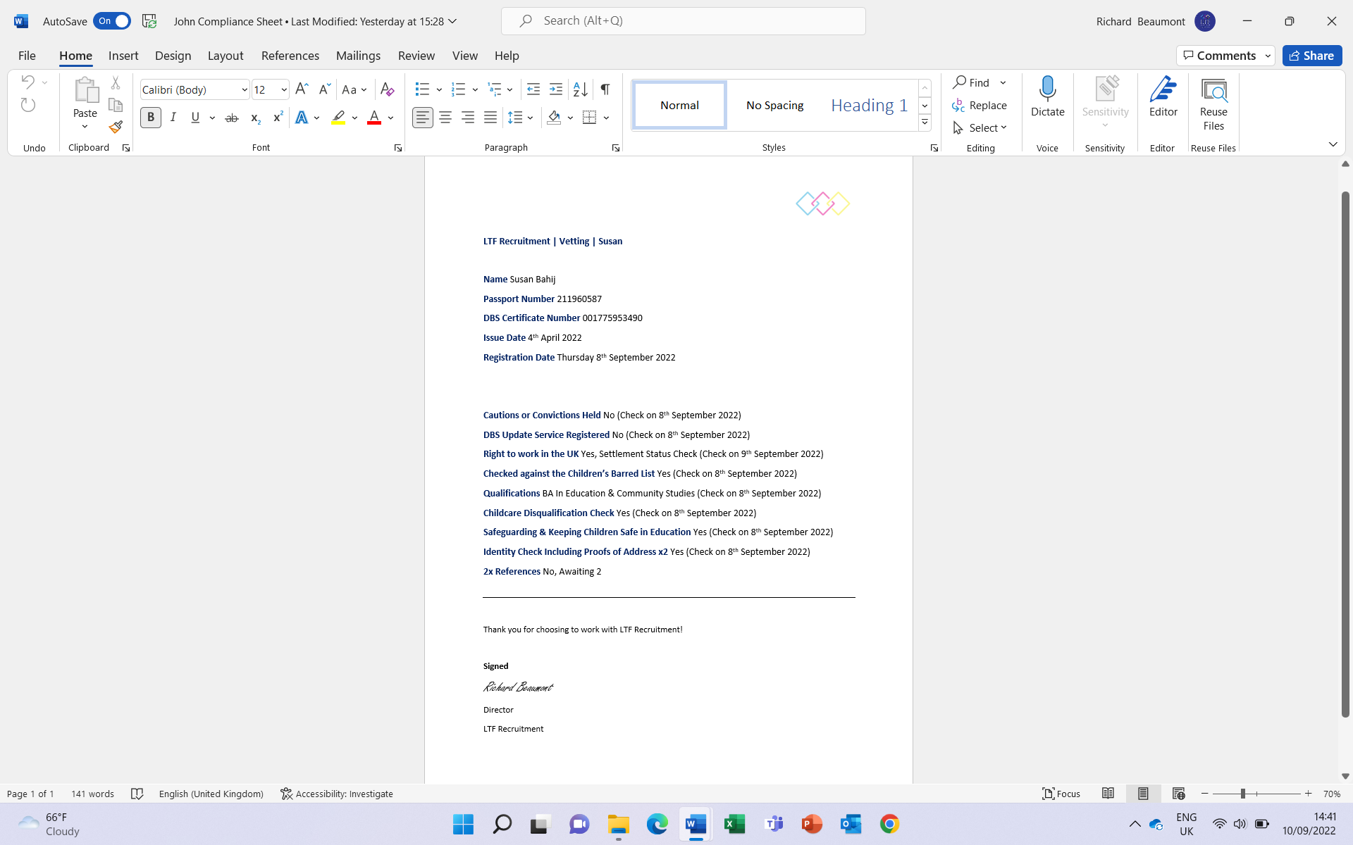
Once candidate has completed registration consultant will need to go through the completed form that comes through the system and check that everything has been received. If not will need to then request more from candidate using push, email or text. Once document has been verified on the system then tick box format again. So two ticks essentially for each document ie one tick to prove consultant has seen passport on video call and one tick to prove that consultant has received same copy of passport document through the reg pack. Remains at X until ticked. Reference requests should be able to be sent from the system by consultant which will be automatically populated using information consultant has already added. Ie referee name, email address and establishment. Once consultant has all correct documents in place they become “compliant” and then will be sent to line manager to approve. Once the line manager approves then the candidate becomes “online” which means they can join the general population of other candidates. Would like a pie chart ideally to show how far along the candidates compliance is. Every time a document is received and verified the pie chart will fill up. Once the candidate is “online” an automated Vetting Form should be created by the system that includes all the checks that we have done in one simple PDF document that we can send straight to schools – example below that we do now manually
Essentially every document we verify needs to be time stamped so that this form can be created. Ie when did the consultant see and verify all the specific documentation. This is very important for schools to see prior to our candidates going in to trial or start a placement. Anything your unsure about from the above we can talk through. But everything else on that picture will have come from the registration pack and time stamped once the candidate has completed the reg form.

Right to work ie passport or residence permit and DBS (police clearance) will both need to have document dates inputted on to the system. Consultant will be notified via pop up and in candidate profile if certain document is going to expire. DBS documents are valid for 3 years if not on the update service. So inputting the issue date will suffice and then 2.5 years from date notification will be sent to consultant via email or pop up. If candidate has DBS registered on the update service then this will need to be checked yearly. This is a service where candidates pay £14 a year to have their DBS renewed without having to pay for a new one. We can search if candidates are on the update service using .GOV website and upload new check each year because of reminder and upload yearly check verification to candidate profile. Passport will need to have the expiry date included on the CRM and consultant reminded 6 months prior using same method.
If a candidate is working through us already that candidate should not be visible on any searches unless the consultant who placed them is looking at candidates they have placed currently.
Consultants should be able to post jobs on Broadbean through CRM.
Consultants should be able to use Evertime while on the CRM
Consultant will be able to add new schools/clients to the system
Consultant will be able to add a clients to the system to populate the database. Ie, name of school, address etc. Once client profile is set up on the system then we should be able to add key contacts in the school ie email address, phone number. And also call log conversations as we do with candidates. Once we make a placement at a particular school that should show up on the client page. We should also be able to create a job for each client from the client page.
Consultants should be able to send candidate profiles to schools on the schools page within the CRM. Then client can send message back to consultant requesting trial/interview etc with details. I am not sure in general how this could work whether through email or purely through CRM but would be great if we could keep all correspondence through CRM. Once client contact has set up their mini profile on the CRM then they will be able to view candidate profile, threads etc and everything I mentioned above. We should be able to send a request to client email to log in to profile to view candidates etc. Client should also be sent terms of business in an automatic email upon showing interest and creating their profile.
Placements
Consultants will have a stand alone page to add placements. This will be a page that just has boxes with headings such as school, candidate, pay rate, charge rate, job role whether they are paid via PAYE or Umbrella company, start date, finish date etc. Then when the consultant types in a school it should show up as a drop down to be clicked. The same with candidate. Once all has been linked together and the placement has been created this should then be reflected in the consultant homepage and should be reflected in margin, days, performance etc. In the same page placements page consultants will have other options such as creating a trial day for a candidate or an interview. So this could be reflected by having a 1st section that has 3 buttons. One for trial day, one for interview and one for placement. Depending on which button the consultant clicks then the relevant form appears to be filled out and completed.
There are two ways that the margin needs to be worked out in the placement section. If consultant clicks PAYE then pay should be x amount. If consultant clicks that candidate is being paid via Umbrella company then it will be a different amount. We can talk about this.
Once the placement, trial day or interview is uploaded to the CRM the client should then automatically receive the vetting form for the candidate. Ideally the vetting form should include links next to each check so that the school can view the digital copy we hold of each document. The candidate will receive the booking confirmation of all the details of the booking ie address, who is the point of contact at the school, the pay rate (if not a trial day or interview as that’s normally unpaid, but occasionally can be), the job role, start time, finish time. Along with our code of conduct as another attachment. We would also like a section so we can add notes to send to both client and candidate once booking is uploaded. For example giving advice to the candidate on their first day or explaining certain things in the vetting form to the client. Clients will receive this via email or their profile on the CRM. Candidates should receive this information by email, text, via the app etc. Maybe the consultant can choose the mode of communication they wish for it to be sent by.
Marketing suite
This is effectively where we want to be able to design the candidate profile that we will send to schools. Where we can add different fonts, logos etc.
Then we also want the system to be able to send the profile once complete to a selection of schools that we choose. So for example I would want to send my candidate John to schools in north east London. So I would send it to all the schools I have on the system who are based in Waltham Forest and Hackney. This would go to the contact that I would choose. For example do I want to send this profile to all headteachers, deputy headteachers, special needs coordinators or business managers within each school. If I have a teacher profile I would send to the headteacher and business manager. If it was a teaching assistant I would send the profile to the special needs coordinator. Obviously we the company have to add all these schools within their respective boroughs and add all contacts for this to be able to work, but this will get better over time. So the filter system when choosing who to market to would go something like. “select location ie London”, “select borough ie Kensington & Chelsea” select type of institution ie primary, secondary or sen school and select “contact” ie headteacher, deputy headteacher, special needs coordinator. This all defines who we are sending this marketing piece to through the system.
This is essentially a mailing tool that would be integral to our CRM.
When the school receive the marketing profile through email they have to be given the option to unsubscribe from the mailing list. That can be included at the bottom of the profile. If this happens then the consultant needs to be notified via pop up in CRM or email.
These profiles then can be saved for future use, or edited to add additional experience.
So essentially we will have a database that includes Clients, Candidates, Placements, Broadbean, Evertime, HR, Marketing suite and Forum/Community page

HR
I and other people I can delegate permissions to need to be able to upload information on to certain consultants HR page on CRM. Need to be able to accept reject holiday, upload contracts, edit and update contracts.
Reports
I want to be able to run reports on consultants actions on the crm during the day. Find out how many candidates were uploaded, reg packs sent out, how many trial days, interviews, placements have been made in a certain period of time that I or a manager can dictate. Basically anything I would need to know about each consultant that the system would permit. Also to be able to group certain consultants reports together. So be able to combine Consultant 1 and Consultant 2 reports to be able to view performance within a certain area. Ie Siobhan is responsible for East Midlands Special Needs Schools and James is responsible for East Midlands Secondary Schools. I would want to view how the East Midlands was doing as a whole and run a report that would show this.
I also want there to be a leaderboards page on the CRM. Using all the stats that I mentioned above. In format of 1st, 2nd 3rd, 4th etc. Candidates uploaded, candidates compliant, interviews, trial days, placements made etc. Also overall margin leaderboard (biggest company billers). Leaderboard should reset to zero at the start of every week (Monday – Sunday). But could be viewed by month, by week and by year to see overall performance.
Admin – what do I need to be able to do (additional access given)
There needs to be a different tier of access on the CRM. Having Master access should grant me the ability to view other consultants CRM profiles. Having basic consultant access should mean that there is no visibility beyond their own system. It might be that we also have another form of access but tailor that access to each person through a filter menu to decide what we can include/exclude in their access/permissions. Or it might be that we have the same profile for everyone but certain permissions can be added or taken away as necessary.
Extra
Two external websites we needed included as a landing page on the CRM (if possible)
- Broadbean – so we can post jobs, search candidates that have applied to our jobs. If integrated within the CRM this is ideal and imperative.
- Evertime – so we can see timesheets, payroll and everything else. If integrated within the CRM this is ideal and imperative.
- The LTF website job board for candidates to be directed to?
The app itself will be a condensed version of everything I have mentioned above. Or it may be you think it could be better having a more specific function. Open to ideas.

